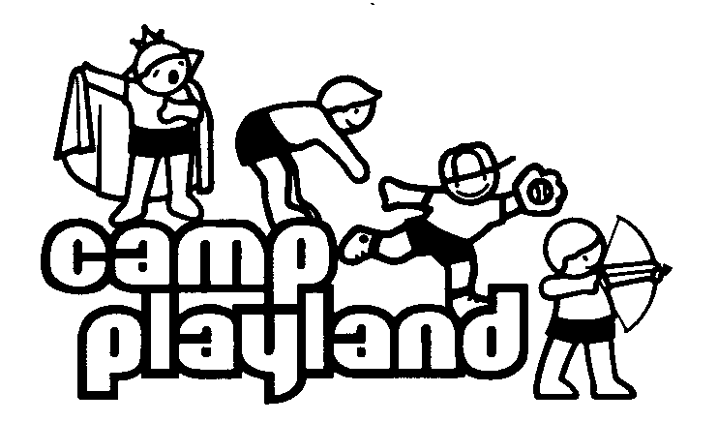 CHIPMUNKS 2016

TIME Monday Tuesday Wednesday Thursday Friday
9:30-9:50 | ATTENDANCE / FLAG RAISING
Period 1  9:50-10:30 | SWIM | ROPES & MATS | SWIM | LACROSSE  BALLFIELD 4 | BOATING & FISHING
Period 2  10:30-11:10 | ARCHERY | SOCCER  BALLFIELD 4 | ARTS & CRAFTS | THEATER | SWIM
Period 3  11:10-11:50 | COURTS | SWIM | PLAY AREA 3 | SWIM | PLAY AREA 2
11:50-12:30 | LUNCH | LUNCH | LUNCH | LUNCH | LUNCH
12:30-1:10 | PLAY/SING | PLAY/SING | PLAY/SING | PLAY/SING | PLAY/SING
Period 4  1:10-1:50 | SWIM | PLAY AREA 1 | SWIM | PLAY AREA 3 | MUSIC
Period 5  1:50-2:30 | NATURE | KARATE  /  GOLF | MUSIC | TENNIS | SWIM
2:30-3:05 | SNACK | SNACK | SNACK | SNACK | SNACK
Period 6  3:05-3:45 | PLAY AREA 1 /  CAMP SITE | SWIM | BASEBALL  BALLFIELD 1 | SWIM | GAMES  BALLFIELD 4
3:45-4:00 | FLAG LOWERING / DISMISSAL

